Mt. Zion Lutheran  March 29th, 2024 | Good Friday | Pastor Mark Brown

Introit Psalm 38:1–4, 18, 22; antiphon: Isaiah 53:5
He was wounded for our transgressions; he was crushed for our iniquities;
upon him was the chastisement that brought us peace, and with his stripes we are healed.
O Lord, rebuke me not in your anger,
nor discipline me in your wrath!
For your arrows have sunk into me,
and your hand has come down on me.
There is no soundness in my flesh because of your indignation;
there is no health in my bones because of my sin.
For my iniquities have gone over my head;
like a heavy burden, they are too heavy for me.
I confess my iniquity;
I am sorry for my sin.
Make haste to help me,
O Lord, my salvation!
He was wounded for our transgressions; he was crushed for our iniquities;
upon him was the chastisement that brought us peace, and with his stripes we are healed.

Prayer
P Let Us Pray
C Almighty God, graciously behold this Your family for whom our Lord Jesus Christ was willing to be betrayed and delivered into the hands of sinful men to suffer death upon the cross; through the same Jesus Christ, Your Son, our Lord, who lives and reigns with You and the Holy Spirit, one God, now and forever.

440 Jesus, I Will Ponder Now sts. 1–4, 6
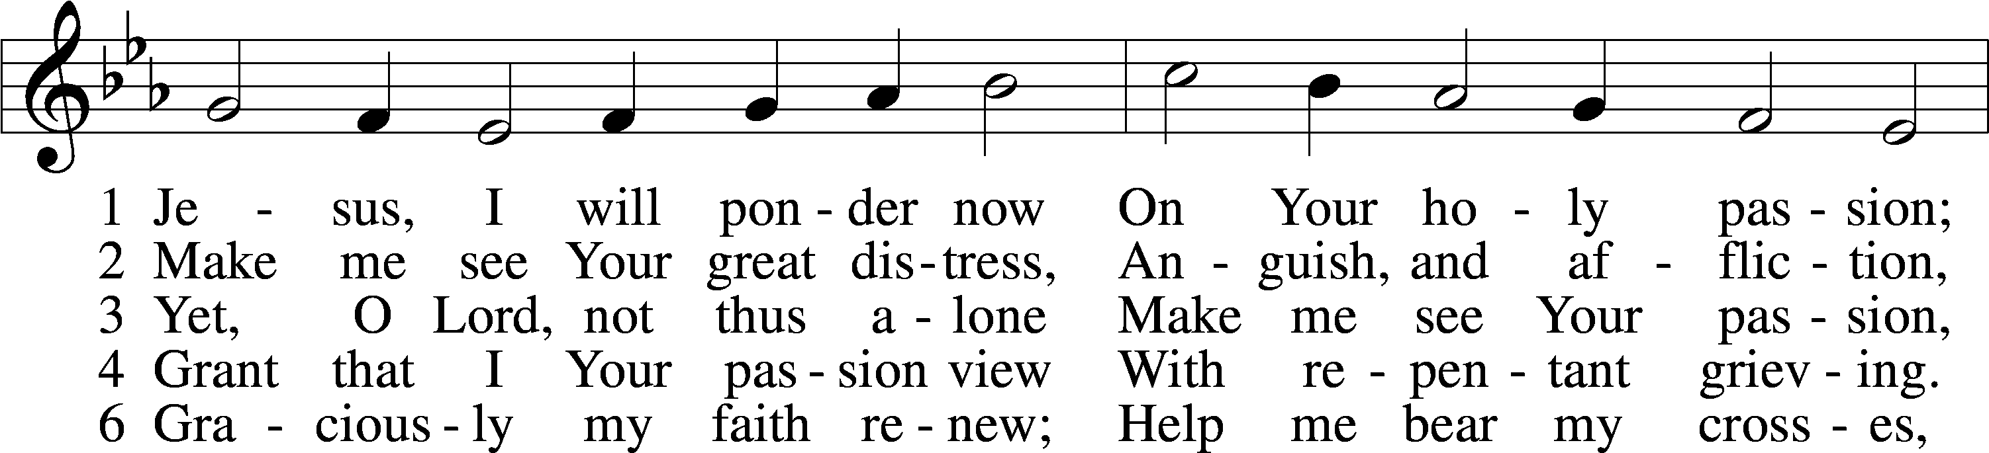
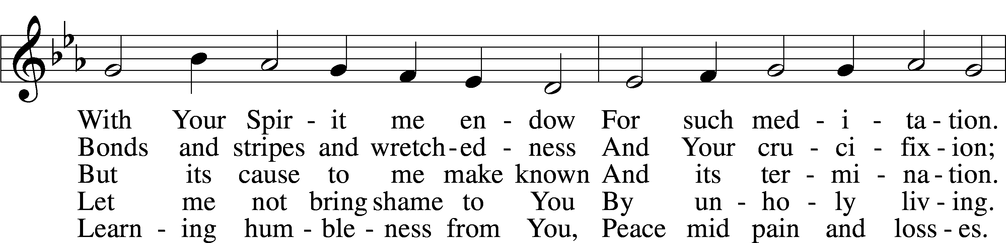
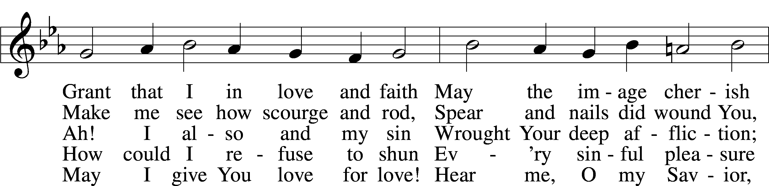
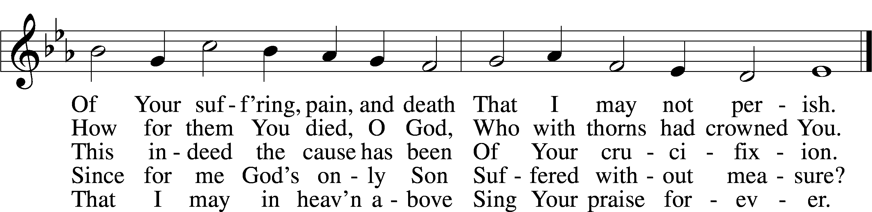
Text: Sigismund von Birken, 1626–81; tr. August Crull, 1845–1923, alt.
Tune: Melchior Vulpius, c. 1570–1615
Text and tune: Public domain

Reading Mark 14:26–31, 66–72
26And when they had sung a hymn, they went out to the Mount of Olives. 27And Jesus said to them, “You will all fall away, for it is written, ‘I will strike the shepherd, and the sheep will be scattered.’ 28But after I am raised up, I will go before you to Galilee.” 29Peter said to him, “Even though they all fall away, I will not.” 30And Jesus said to him, “Truly, I tell you, this very night, before the rooster crows twice, you will deny me three times.” 31But he said emphatically, “If I must die with you, I will not deny you.” And they all said the same.
66And as Peter was below in the courtyard, one of the servant girls of the high priest came, 67and seeing Peter warming himself, she looked at him and said, “You also were with the Nazarene, Jesus.” 68But he denied it, saying, “I neither know nor understand what you mean.” And he went out into the gateway and the rooster crowed. 69And the servant girl saw him and began again to say to the bystanders, “This man is one of them.” 70But again he denied it. And after a little while the bystanders again said to Peter, “Certainly you are one of them, for you are a Galilean.” 71But he began to invoke a curse on himself and to swear, “I do not know this man of whom you speak.” 72And immediately the rooster crowed a second time. And Peter remembered how Jesus had said to him, “Before the rooster crows twice, you will deny me three times.” And he broke down and wept.

437 Alas! And Did My Savior Bleed sts. 1–2, 4
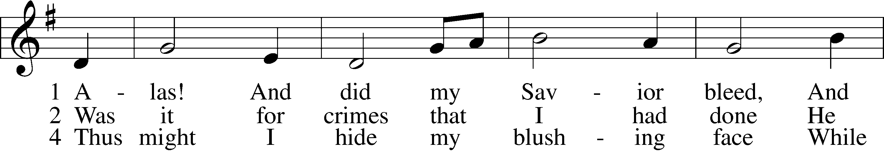
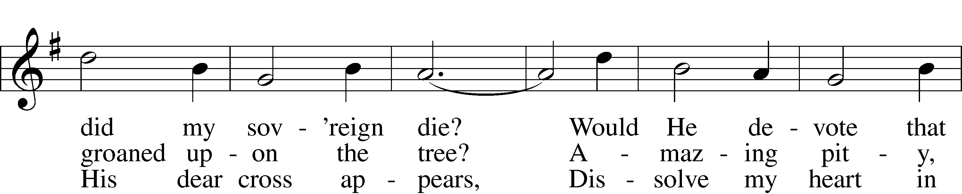
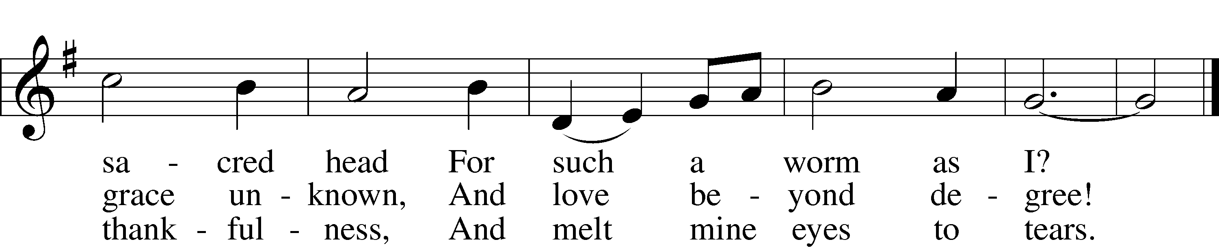
Text: Isaac Watts, 1674–1748, alt.
Tune: Hugh Wilson, 1764–1824
Text and tune: Public domain

Meditation

Dowsing of the Light

Reading Mark 14:32–42
32And they went to a place called Gethsemane. And he said to his disciples, “Sit here while I pray.” 33And he took with him Peter and James and John, and began to be greatly distressed and troubled. 34And he said to them, “My soul is very sorrowful, even to death. Remain here and watch.” 35And going a little farther, he fell on the ground and prayed that, if it were possible, the hour might pass from him. 36And he said, “Abba, Father, all things are possible for you. Remove this cup from me. Yet not what I will, but what you will.” 37And he came and found them sleeping, and he said to Peter, “Simon, are you asleep? Could you not watch one hour? 38Watch and pray that you may not enter into temptation. The spirit indeed is willing, but the flesh is weak.” 39And again he went away and prayed, saying the same words. 40And again he came and found them sleeping, for their eyes were very heavy, and they did not know what to answer him. 41And he came the third time and said to them, “Are you still sleeping and taking your rest? It is enough; the hour has come. The Son of Man is betrayed into the hands of sinners. 42Rise, let us be going; see, my betrayer is at hand.”

436 Go to Dark Gethsemane sts. 1–2
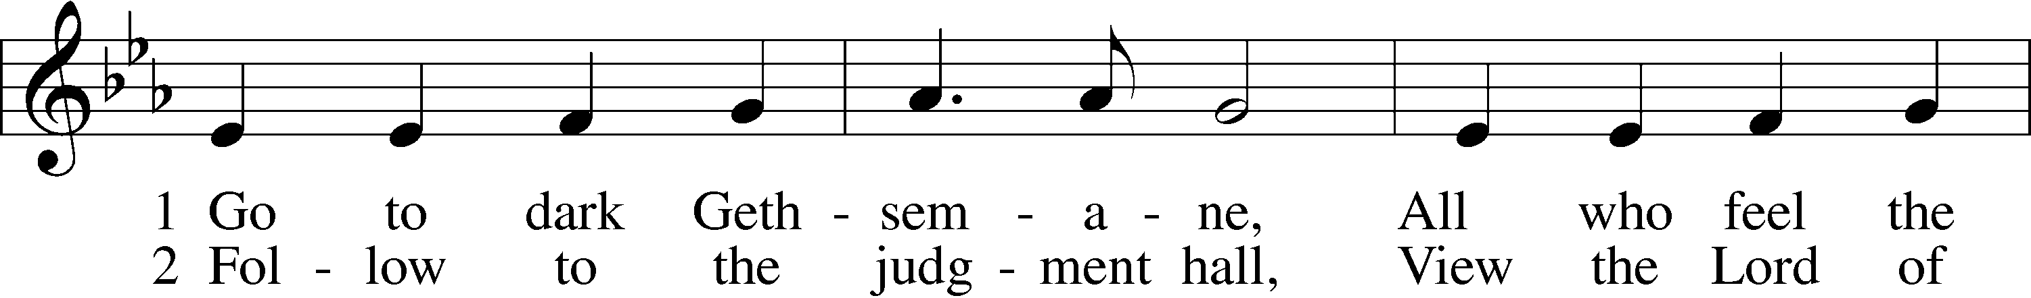
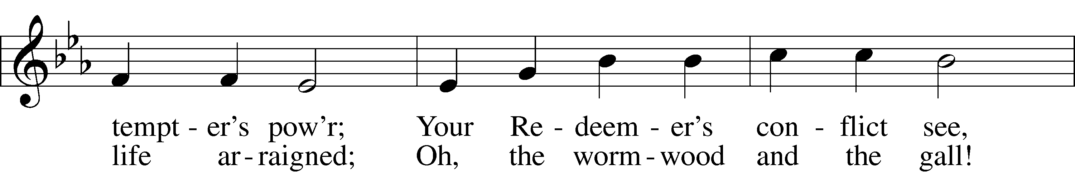
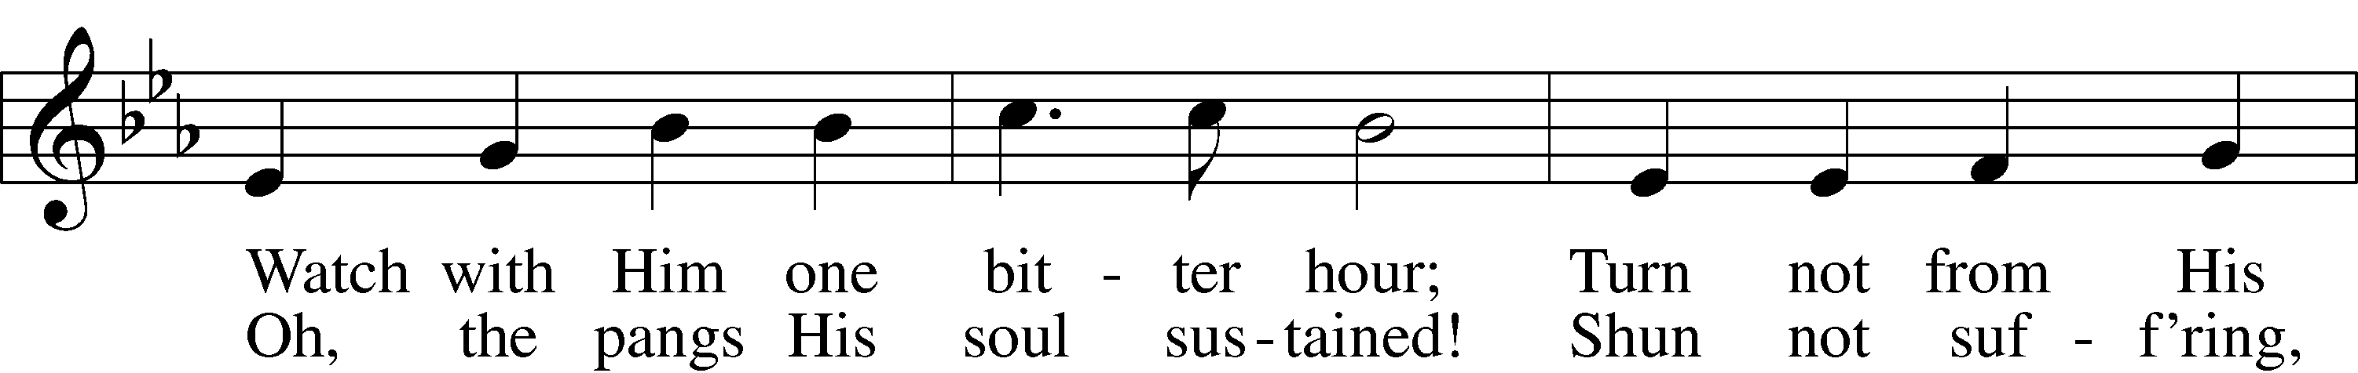
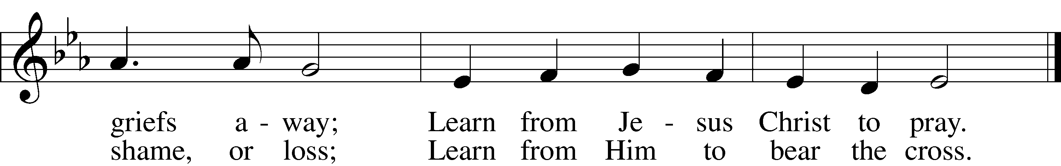
Text: James Montgomery, 1771–1854
Tune: Richard Redhead, 1820–1901
Text and tune: Public domain

Meditation

Dowsing of the Light

Reading Mark 14:43–52
43And immediately, while he was still speaking, Judas came, one of the twelve, and with him a crowd with swords and clubs, from the chief priests and the scribes and the elders. 44Now the betrayer had given them a sign, saying, “The one I will kiss is the man. Seize him and lead him away under guard.” 45And when he came, he went up to him at once and said, “Rabbi!” And he kissed him. 46And they laid hands on him and seized him. 47But one of those who stood by drew his sword and struck the servant of the high priest and cut off his ear. 48And Jesus said to them, “Have you come out as against a robber, with swords and clubs to capture me? 49Day after day I was with you in the temple teaching, and you did not seize me. But let the Scriptures be fulfilled.” 50And they all left him and fled.
51And a young man followed him, with nothing but a linen cloth about his body. And they seized him, 52but he left the linen cloth and ran away naked.

451 Stricken, Smitten, and Afflicted sts. 1–3
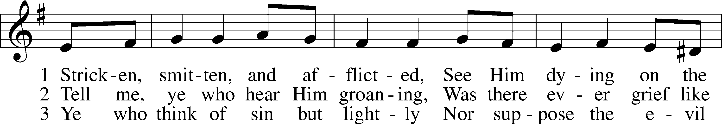
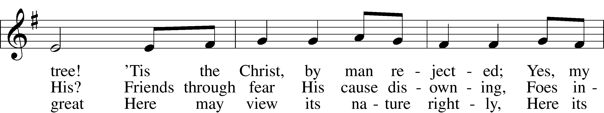
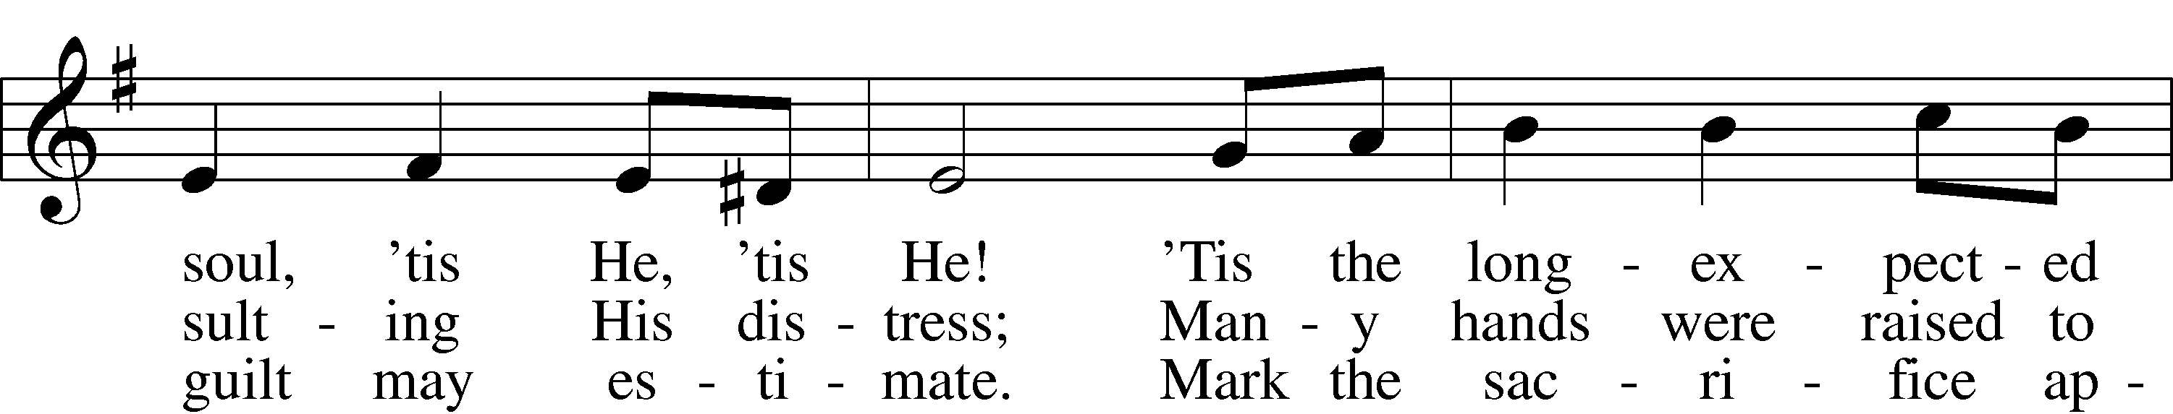
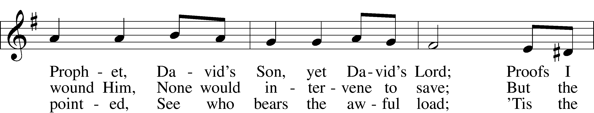
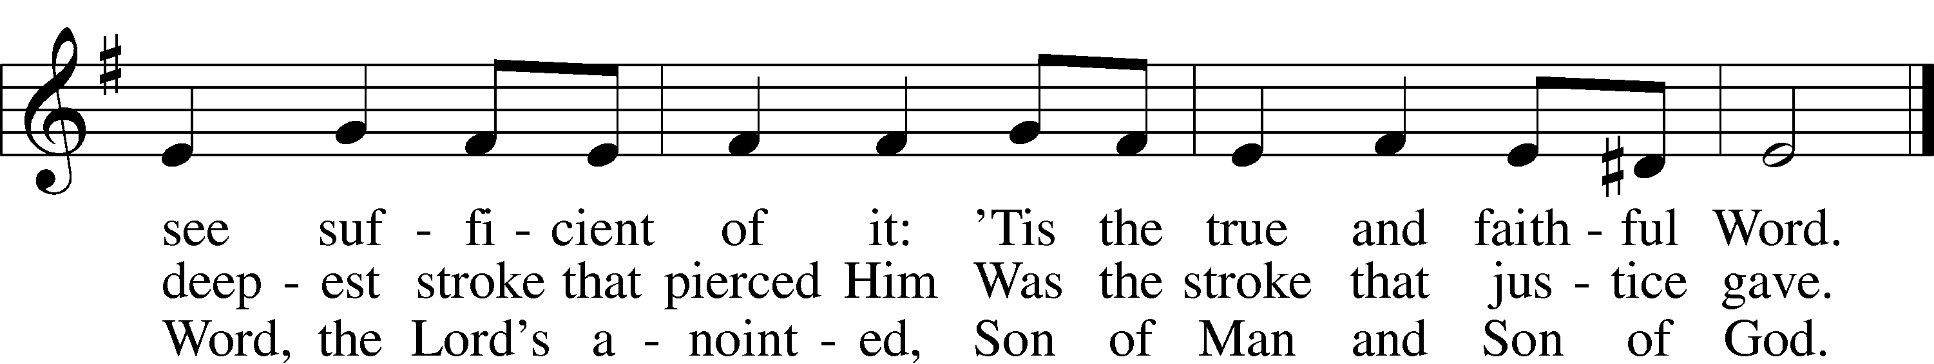
Text: Thomas Kelly, 1769–1855, alt.
Tune: Geistliche Volkslieder, 1850, Paderborn
Text and tune: Public domain

Meditation

Dowsing of the Light

Reading Mark 14:53–65
53And they led Jesus to the high priest. And all the chief priests and the elders and the scribes came together. 54And Peter had followed him at a distance, right into the courtyard of the high priest. And he was sitting with the guards and warming himself at the fire. 55Now the chief priests and the whole Council were seeking testimony against Jesus to put him to death, but they found none. 56For many bore false witness against him, but their testimony did not agree. 57And some stood up and bore false witness against him, saying, 58“We heard him say, ‘I will destroy this temple that is made with hands, and in three days I will build another, not made with hands.’” 59Yet even about this their testimony did not agree. 60And the high priest stood up in the midst and asked Jesus, “Have you no answer to make? What is it that these men testify against you?” 61But he remained silent and made no answer. Again the high priest asked him, “Are you the Christ, the Son of the Blessed?” 62And Jesus said, “I am, and you will see the Son of Man seated at the right hand of Power, and coming with the clouds of heaven.” 63And the high priest tore his garments and said, “What further witnesses do we need? 64You have heard his blasphemy. What is your decision?” And they all condemned him as deserving death. 65And some began to spit on him and to cover his face and to strike him, saying to him, “Prophesy!” And the guards received him with blows.

439 O Dearest Jesus, What Law Hast Thou Broken sts. 1, 3
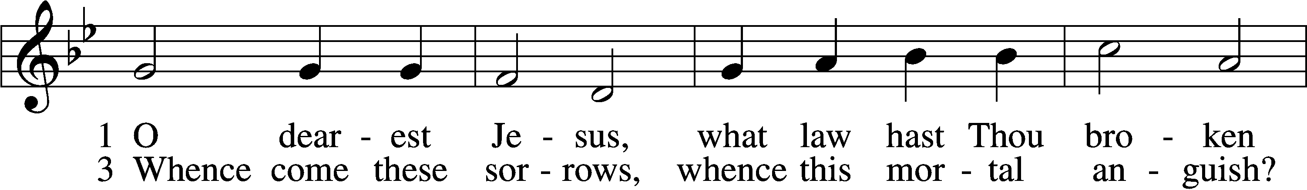
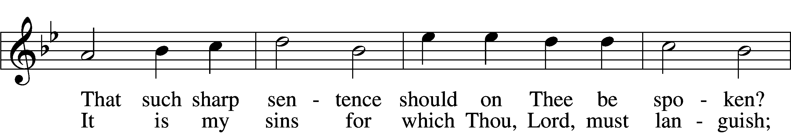
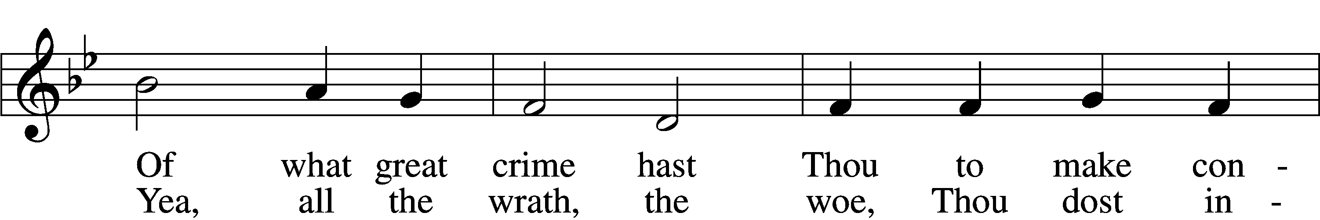
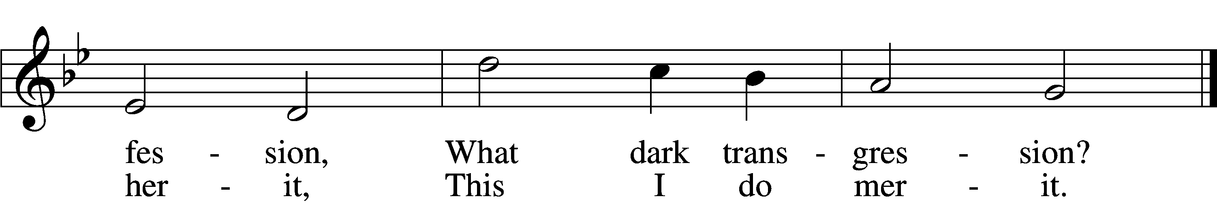
Text: Johann Heermann, 1585–1647; tr. Catherine Winkworth, 1827–78, alt.
Tune: Johann Crüger, 1598–1662
Text and tune: Public domain

Meditation

Dowsing of the Light

Reading Mark 15:1–15
1And as soon as it was morning, the chief priests held a consultation with the elders and scribes and the whole Council. And they bound Jesus and led him away and delivered him over to Pilate. 2And Pilate asked him, “Are you the King of the Jews?” And he answered him, “You have said so.” 3And the chief priests accused him of many things. 4And Pilate again asked him, “Have you no answer to make? See how many charges they bring against you.” 5But Jesus made no further answer, so that Pilate was amazed.
6Now at the feast he used to release for them one prisoner for whom they asked. 7And among the rebels in prison, who had committed murder in the insurrection, there was a man called Barabbas. 8And the crowd came up and began to ask Pilate to do as he usually did for them. 9And he answered them, saying, “Do you want me to release for you the King of the Jews?” 10For he perceived that it was out of envy that the chief priests had delivered him up. 11But the chief priests stirred up the crowd to have him release for them Barabbas instead. 12And Pilate again said to them, “Then what shall I do with the man you call the King of the Jews?” 13And they cried out again, “Crucify him.” 14And Pilate said to them, “Why, what evil has he done?” But they shouted all the more, “Crucify him.” 15So Pilate, wishing to satisfy the crowd, released for them Barabbas, and having scourged Jesus, he delivered him to be crucified.

430 My Song Is Love Unknown sts. 1–5
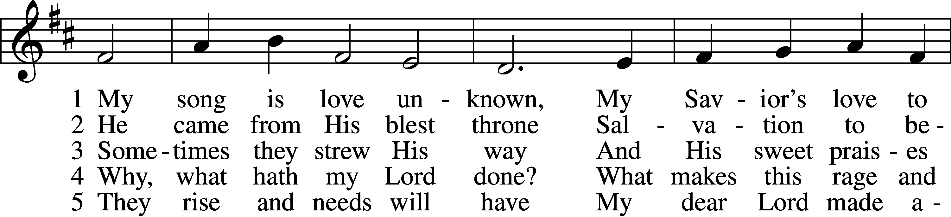
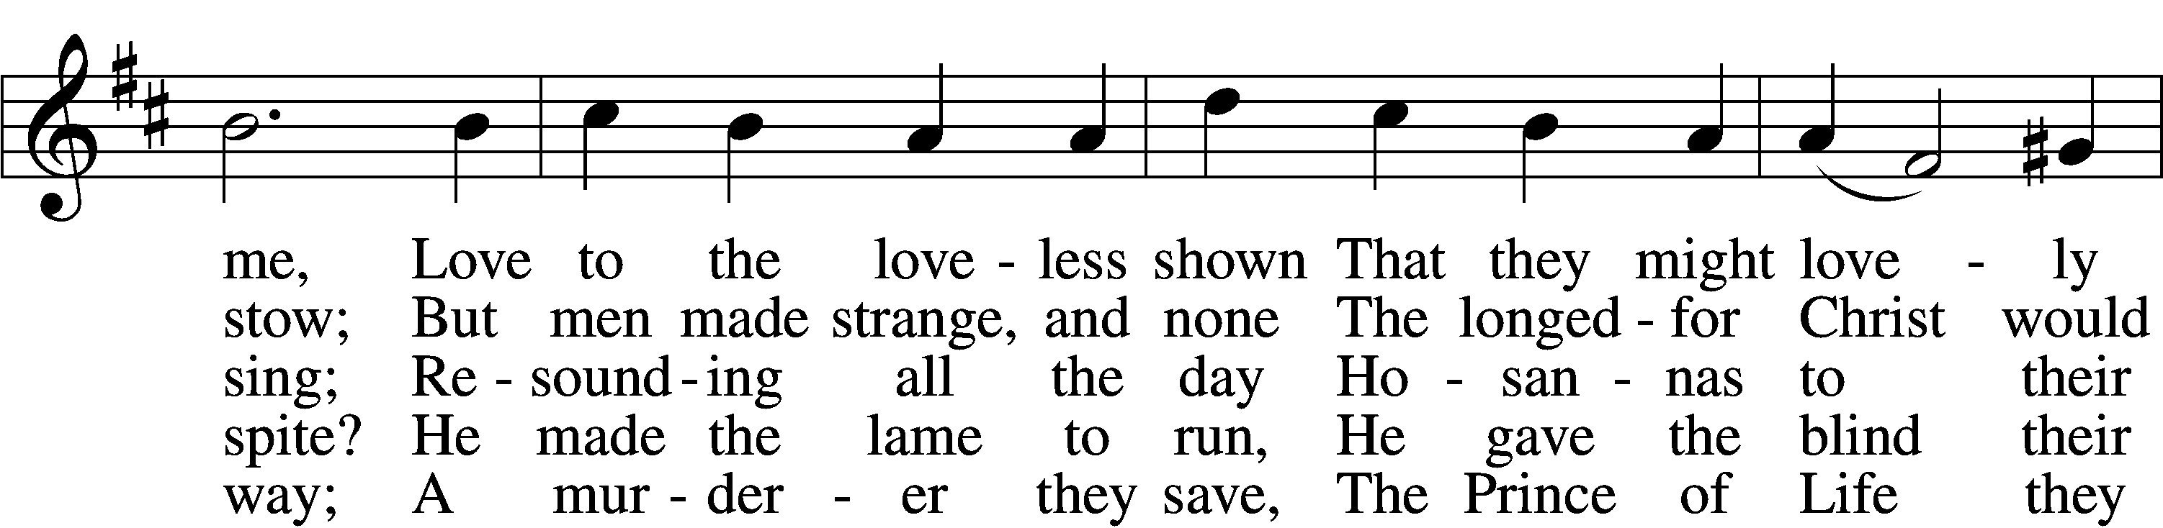
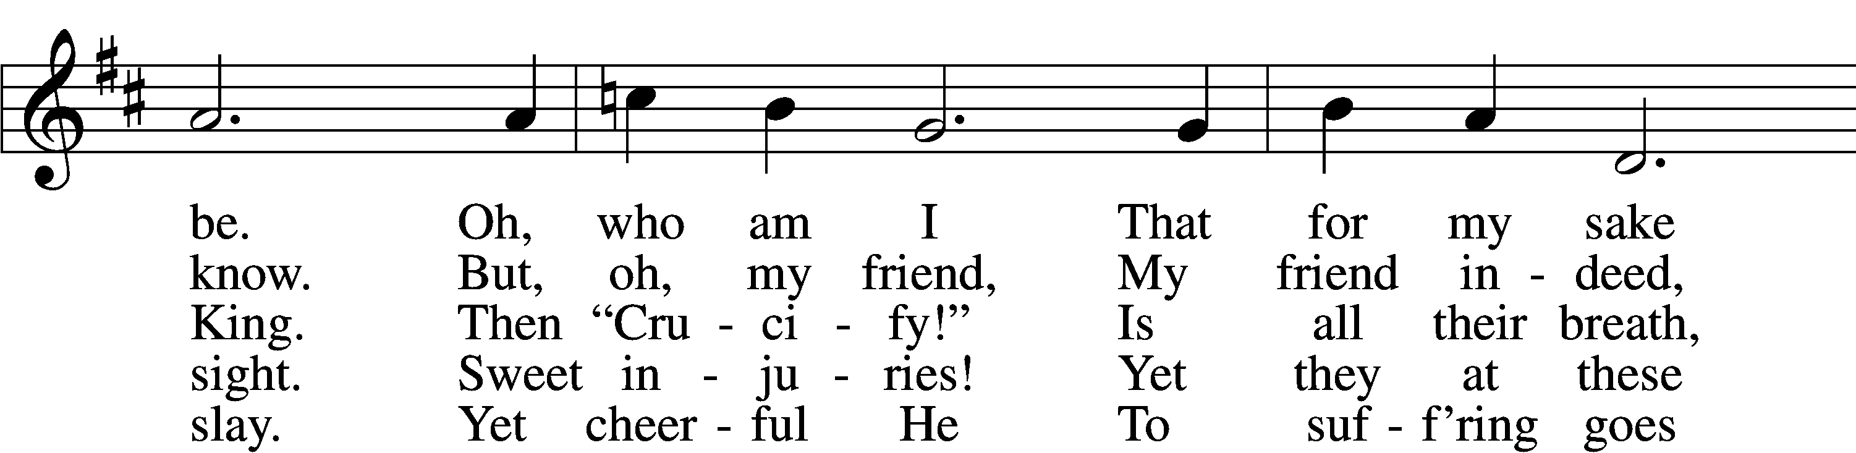
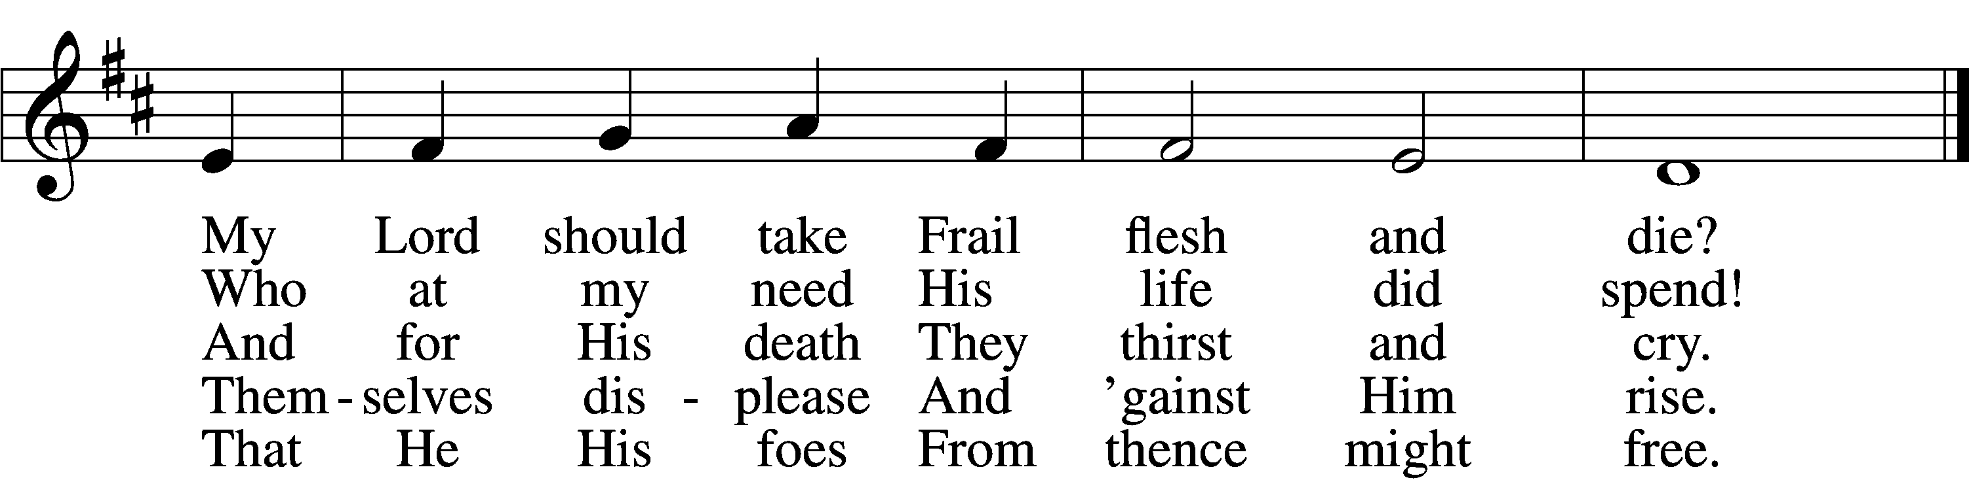
Text: Samuel Crossman, c. 1624–1683
Tune: John N. Ireland, 1879–1962
Text: Public domain
Tune: © John Ireland Trust. Used by permission: LSB Hymn License no. 110018477

Meditation

Dowsing of the Light

Reading Mark 15:21–41
21And they compelled a passerby, Simon of Cyrene, who was coming in from the country, the father of Alexander and Rufus, to carry his cross. 22And they brought him to the place called Golgotha (which means Place of a Skull). 23And they offered him wine mixed with myrrh, but he did not take it. 24And they crucified him and divided his garments among them, casting lots for them, to decide what each should take. 25And it was the third hour when they crucified him. 26And the inscription of the charge against him read, “The King of the Jews.” 27And with him they crucified two robbers, one on his right and one on his left. 29And those who passed by derided him, wagging their heads and saying, “Aha! You who would destroy the temple and rebuild it in three days, 30save yourself, and come down from the cross!” 31So also the chief priests with the scribes mocked him to one another, saying, “He saved others; he cannot save himself. 32Let the Christ, the King of Israel, come down now from the cross that we may see and believe.” Those who were crucified with him also reviled him.
33And when the sixth hour had come, there was darkness over the whole land until the ninth hour. 34And at the ninth hour Jesus cried with a loud voice, “Eloi, Eloi, lema sabachthani?” which means, “My God, my God, why have you forsaken me?” 35And some of the bystanders hearing it said, “Behold, he is calling Elijah.” 36And someone ran and filled a sponge with sour wine, put it on a reed and gave it to him to drink, saying, “Wait, let us see whether Elijah will come to take him down.” 37And Jesus uttered a loud cry and breathed his last. 38And the curtain of the temple was torn in two, from top to bottom. 39And when the centurion, who stood facing him, saw that in this way he breathed his last, he said, “Truly this man was the Son of God!”
40There were also women looking on from a distance, among whom were Mary Magdalene, and Mary the mother of James the younger and of Joses, and Salome. 41When he was in Galilee, they followed him and ministered to him, and there were also many other women who came up with him to Jerusalem.

432 In Silent Pain the Eternal Son
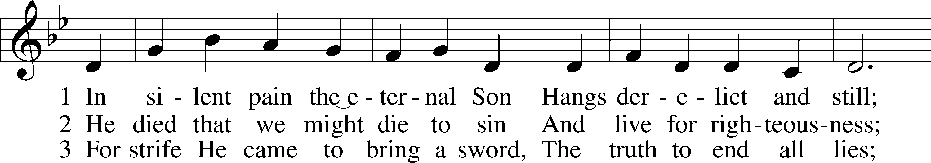
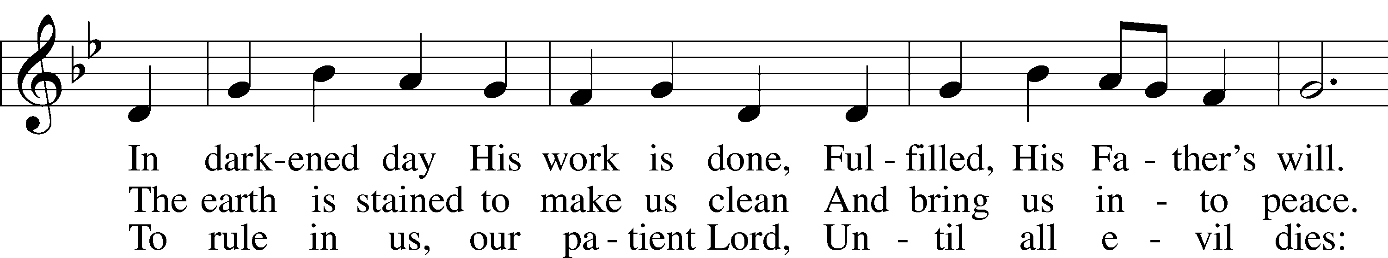
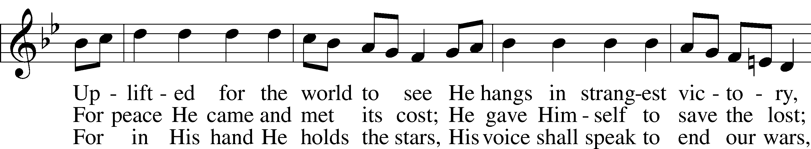
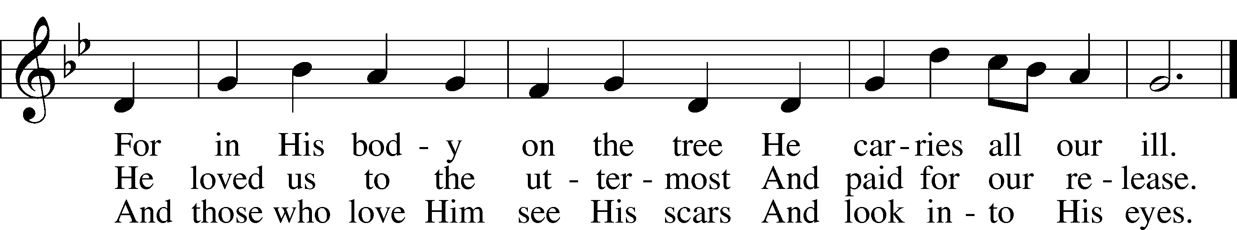
Text: Christopher M. Idle, 1938
Tune: John L. Bell, 1949
Text: © 1992 The Jubilate Group, admin. Hope Publishing Co. Used by permission: LSB Hymn License no. 110018477
Tune: © 1988, 1997 Wild Goose Resource Group, Iona Community, Scotland, admin. GIA Publications, Inc. Used by permission: LSB Hymn License no. 110018477

Meditation

Dowsing of the Light

Reading Mark 15:42–47
42And when evening had come, since it was the day of Preparation, that is, the day before the Sabbath, 43Joseph of Arimathea, a respected member of the Council, who was also himself looking for the kingdom of God, took courage and went to Pilate and asked for the body of Jesus. 44Pilate was surprised to hear that he should have already died. And summoning the centurion, he asked him whether he was already dead. 45And when he learned from the centurion that he was dead, he granted the corpse to Joseph. 46And Joseph bought a linen shroud, and taking him down, wrapped him in the linen shroud and laid him in a tomb that had been cut out of the rock. And he rolled a stone against the entrance of the tomb. 47Mary Magdalene and Mary the mother of Joses saw where he was laid.

456 Were You There sts. 1–3
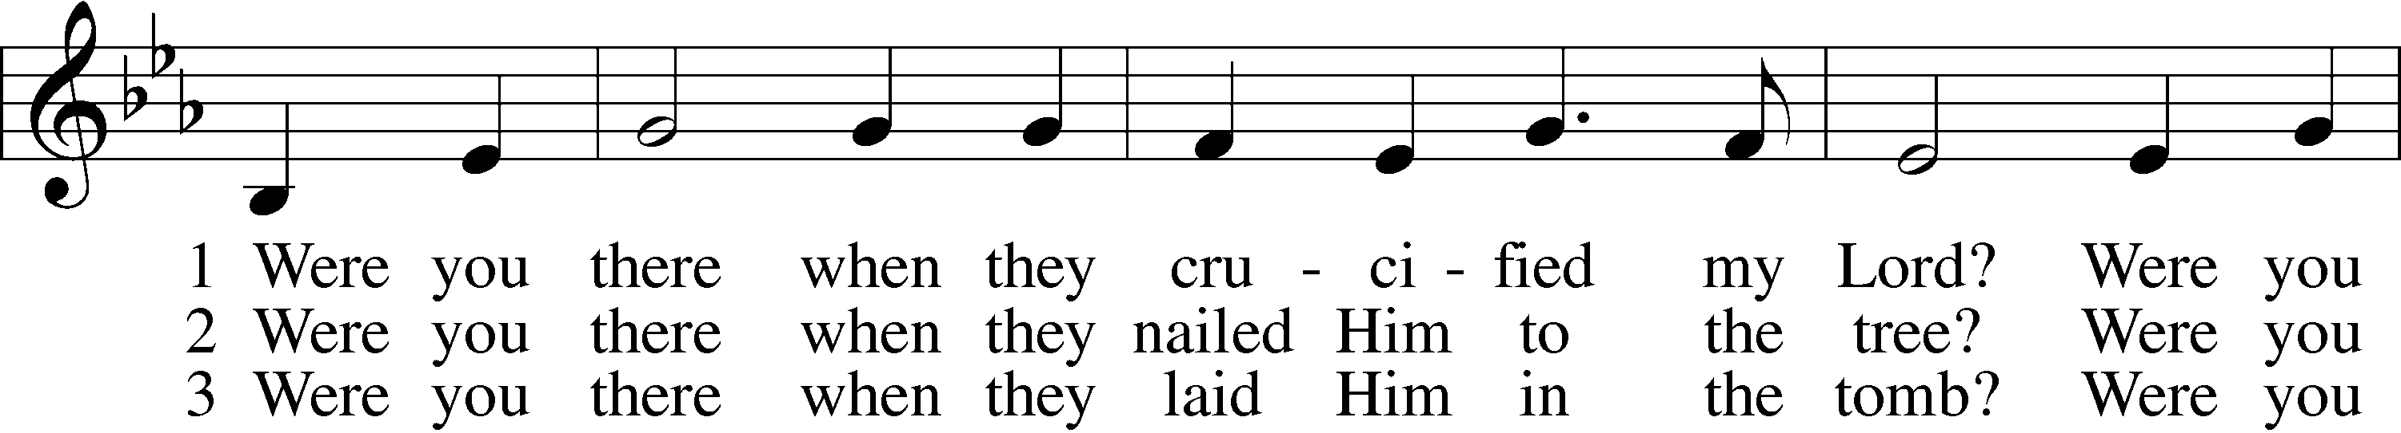
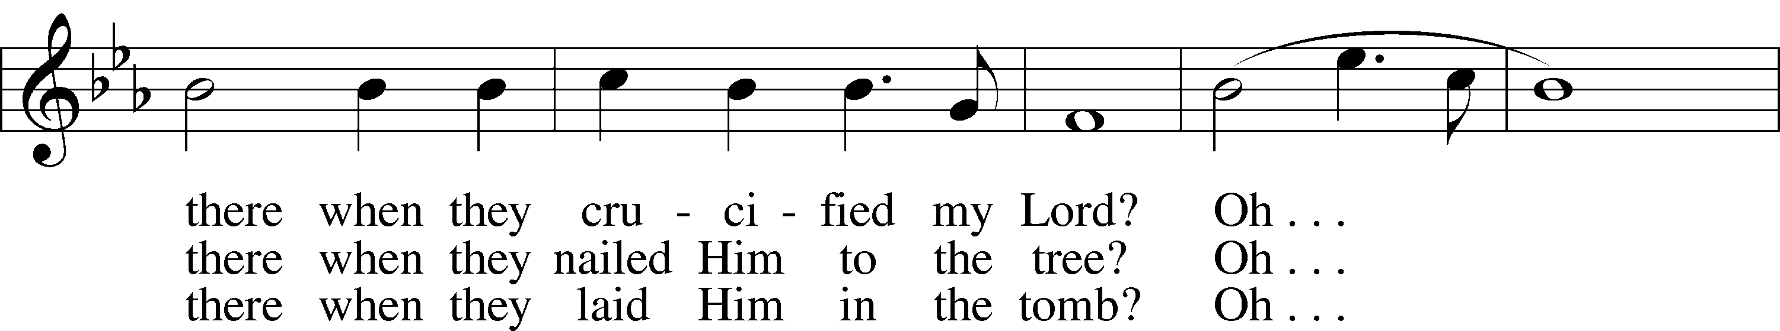
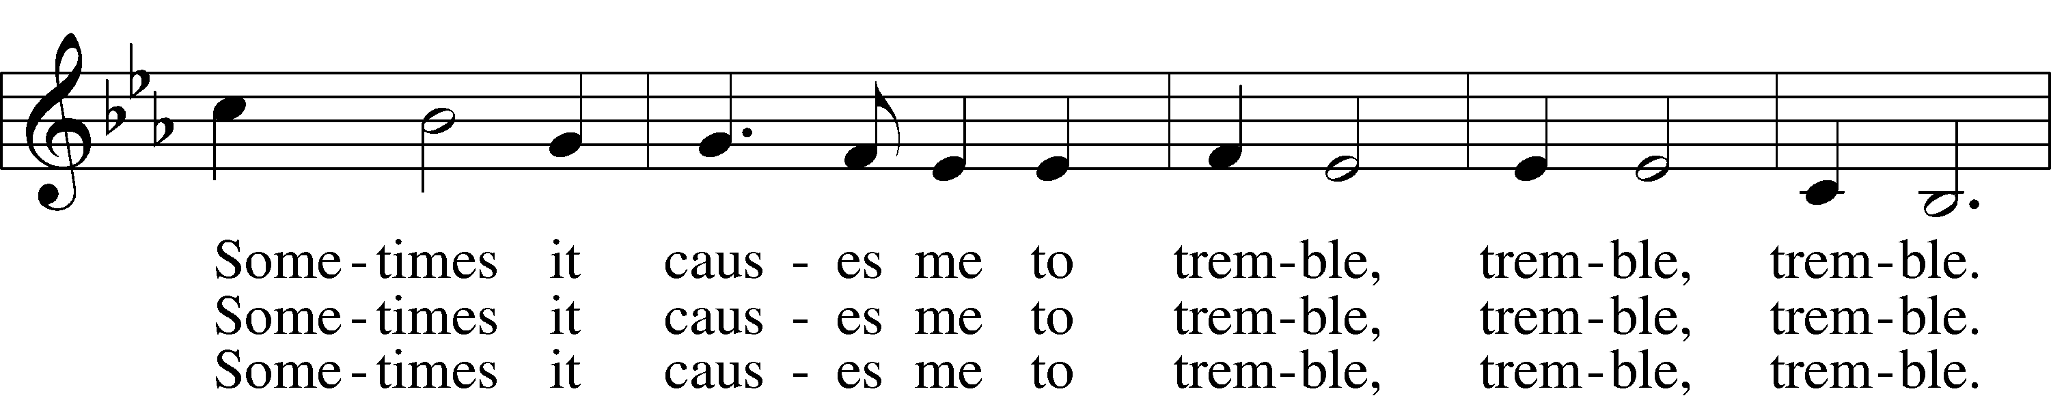
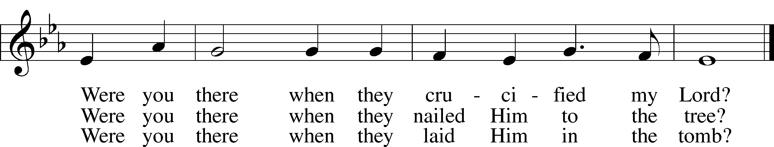
Text and tune: African American spiritual, 19th cent., alt.
Text and tune: Public domain

Mediation

Dowsing of the Light

Lord’s Prayer LSB 251
L Taught by our Lord and trusting His promises, we are bold to pray:
C Our Father who art in heaven,
hallowed be Thy name,
Thy kingdom come,
Thy will be done on earth
as it is in heaven;
give us this day our daily bread;
and forgive us our trespasses
as we forgive those
who trespass against us;
and lead us not into temptation,
but deliver us from evil.
For Thine is the kingdom
and the power and the glory
forever and ever. Amen.

Congregants May Remain in Contemplation

Congregation Leaves in Silence in the Hope of the Resurrection

Acknowledgments
Unless otherwise indicated, Scripture quotations are from the ESV® Bible (The Holy Bible, English Standard Version®), copyright © 2001 by Crossway, a publishing ministry of Good News Publishers. Used by permission. All rights reserved.
Created by Lutheran Service Builder © 2024 Concordia Publishing House.

