
Mt. Zion Lutheran  October 25th, 2025 | Funeral Service for  Sharon Witzke | Pastor Mark Brown

Prelude: “Peace, Perfect Peace”, Meditation for Organ, E.McCluskey,editor.

656 A Mighty Fortress Is Our God
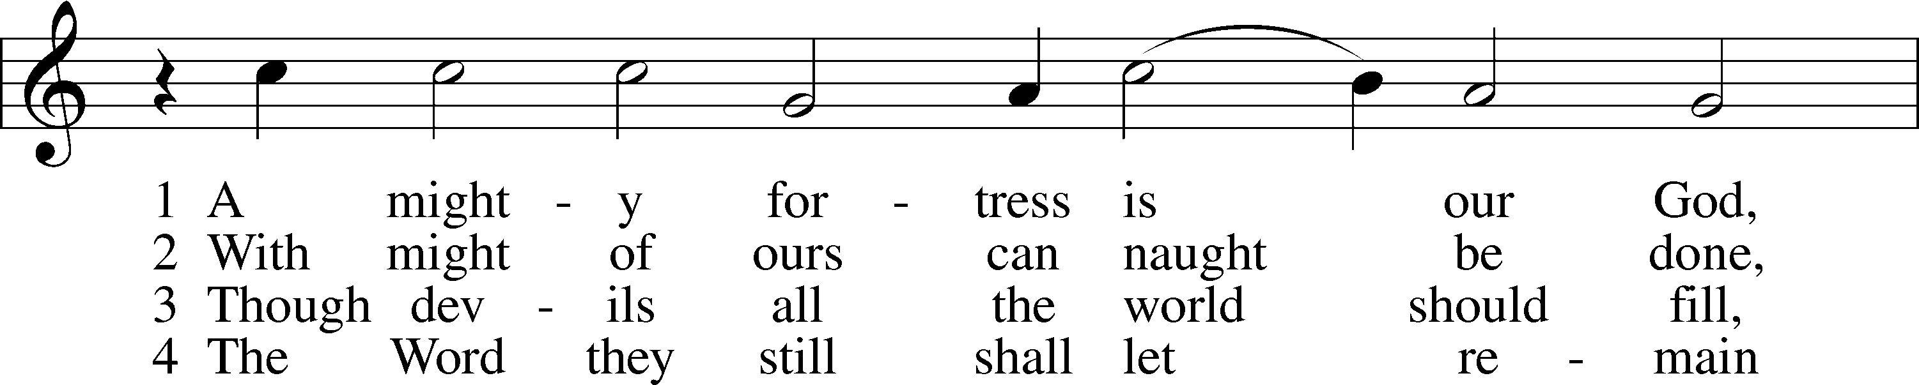
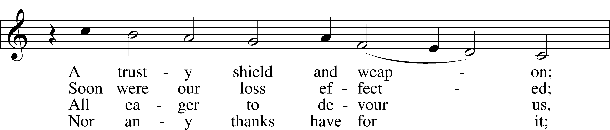
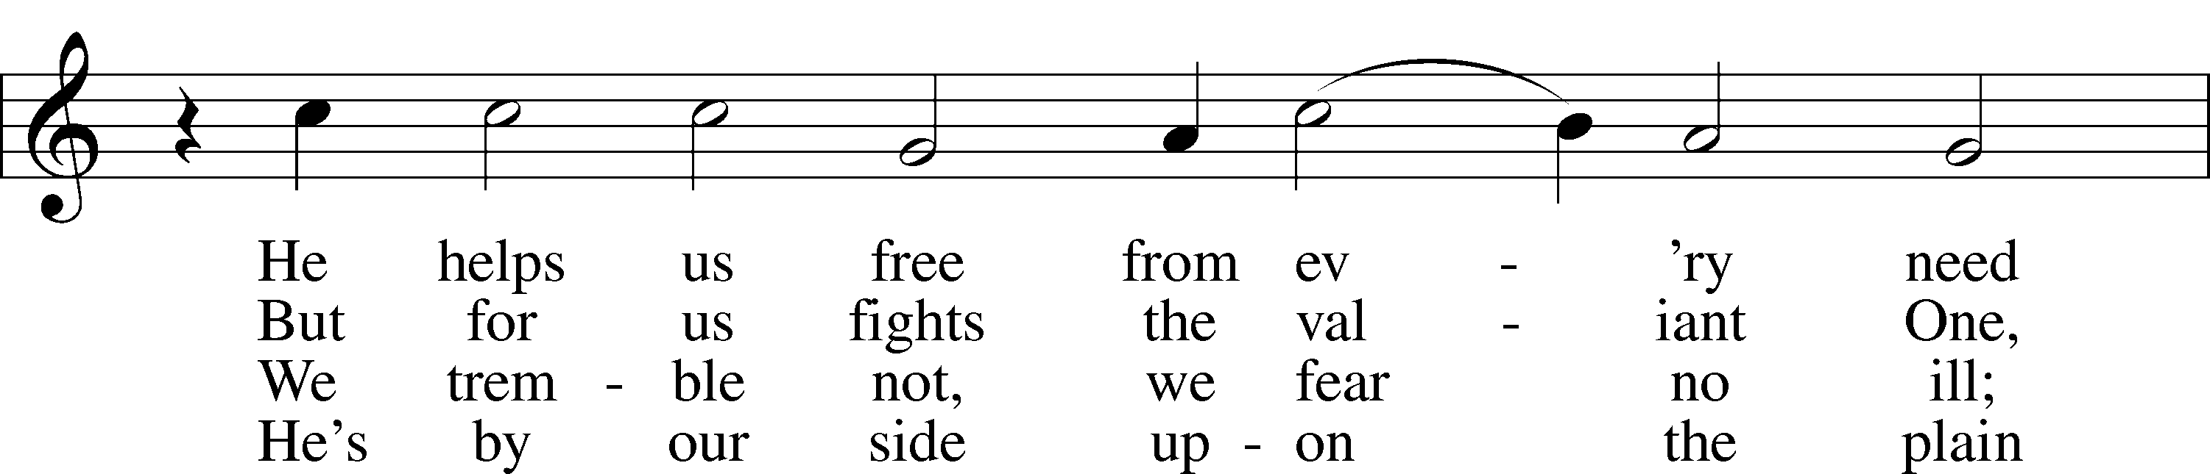
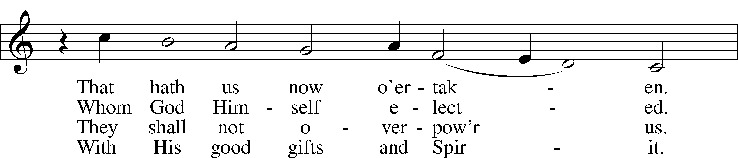
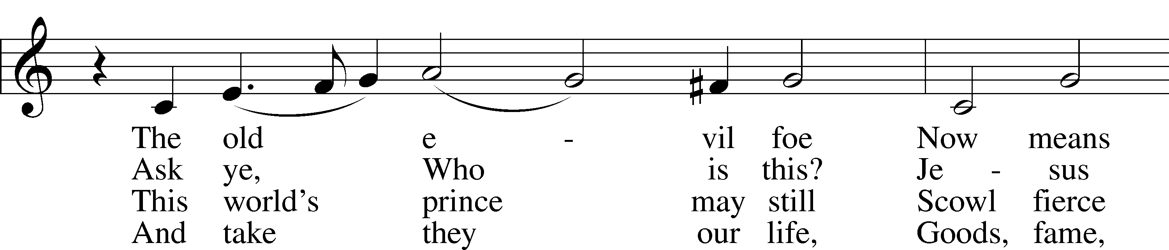
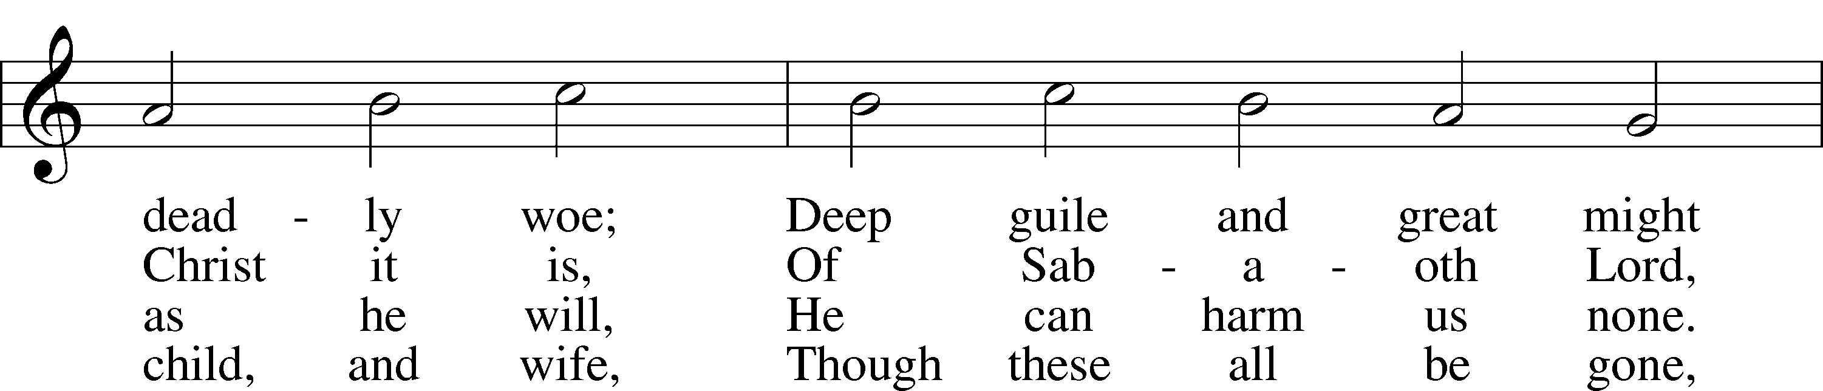
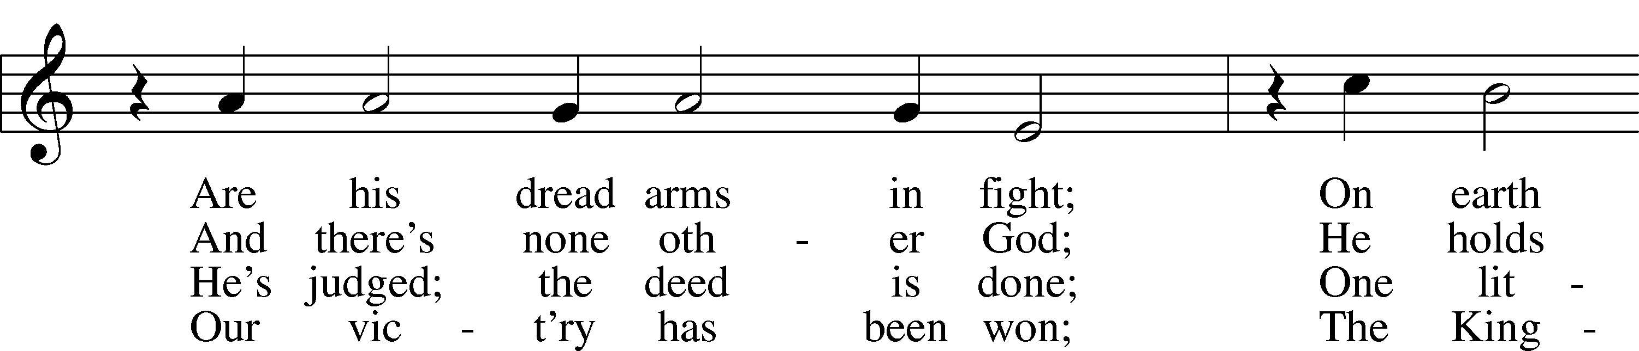
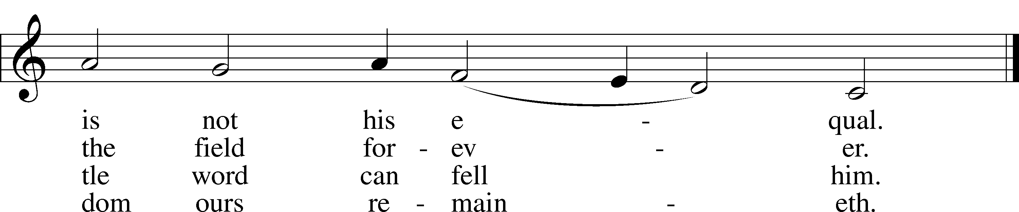
Text: tr. composite
Text and tune: Martin Luther, 1483–1546
Text and tune: Public domain

Obituary & Family Remembrance

Stand

Invocation
P In the name of the Father and of the T Son and of the Holy Spirit.
C Amen.

Remembrance of Baptism
P In Holy Baptism Sharon was clothed with the robe of Christ’s righteousness that covered all her sin. St. Paul says: “Do you not know that all of us who have been baptized into Christ Jesus were baptized into His death?”
C We were buried therefore with Him by baptism into death, in order that, just as Christ was raised from the dead by the glory of the Father, we too might walk in newness of life. For if we have been united with Him in a death like His, we shall certainly be united with Him in a resurrection like His.

Psalm 23 Psalm 23
1The Lord is my shepherd;
I shall not want.
2He makes me lie down in green pastures.
He leads me beside still waters.
3He restores my soul.
He leads me in paths of righteousness for his name’s sake.
4Even though I walk through the valley of the shadow of death,
I will fear no evil, for you are with me;
your rod and your staff, they comfort me.
5You prepare a table before me
in the presence of my enemies;
you anoint my head with oil;
my cup overflows.
6Surely goodness and mercy shall follow me
all the days of my life,
and I shall dwell in the house of the Lord forever.

Kyrie
P Lord, have mercy upon us.
C Christ, have mercy upon us.
Lord, have mercy upon us.

Salutation and Collect of the Day
P The Lord be with you.
C And also with you.

P Let us pray.
O God of grace and mercy, we give thanks for Your loving-kindness shown to Sharon and to all Your servants who, having finished their course in faith, now rest from their labors. Grant that we also may be faithful unto death and receive the crown of eternal life; through Jesus Christ, Your Son, our Lord, who lives and reigns with You and the Holy Spirit, one God, now and forever.
C Amen.

Sit

First Reading Revelation 7:9–17
9After this I looked, and behold, a great multitude that no one could number, from every nation, from all tribes and peoples and languages, standing before the throne and before the Lamb, clothed in white robes, with palm branches in their hands, 10and crying out with a loud voice, “Salvation belongs to our God who sits on the throne, and to the Lamb!” 11And all the angels were standing around the throne and around the elders and the four living creatures, and they fell on their faces before the throne and worshiped God, 12saying, “Amen! Blessing and glory and wisdom and thanksgiving and honor and power and might be to our God forever and ever! Amen.”
13Then one of the elders addressed me, saying, “Who are these, clothed in white robes, and from where have they come?” 14I said to him, “Sir, you know.” And he said to me, “These are the ones coming out of the great tribulation. They have washed their robes and made them white in the blood of the Lamb.
15“Therefore they are before the throne of God,
and serve him day and night in his temple;
and he who sits on the throne will shelter them with his presence.
16They shall hunger no more, neither thirst anymore;
the sun shall not strike them,
nor any scorching heat.
17For the Lamb in the midst of the throne will be their shepherd,
and he will guide them to springs of living water,
and God will wipe away every tear from their eyes.”

A This is the Word of the Lord.
C Thanks be to God.

Soloist Erin: "The Lord's Prayer"

Holy Gospel John 14:1–6
P The Holy Gospel according to St. John, the fourteenth chapter.
C Glory to You, O Lord.

1“Let not your hearts be troubled. Believe in God; believe also in me. 2In my Father’s house are many rooms. If it were not so, would I have told you that I go to prepare a place for you? 3And if I go and prepare a place for you, I will come again and will take you to myself, that where I am you may be also. 4And you know the way to where I am going.” 5Thomas said to him, “Lord, we do not know where you are going. How can we know the way?” 6Jesus said to him, “I am the way, and the truth, and the life. No one comes to the Father except through me.

P This is the Gospel of the Lord.
C Praise to You, O Christ.

Apostles’ Creed
P God has made us His people through our Baptism into Christ. Living together in trust and hope, we confess our faith.
C I believe in God, the Father Almighty,
maker of heaven and earth.
And in Jesus Christ, His only Son, our Lord,
who was conceived by the Holy Spirit,
born of the virgin Mary,
suffered under Pontius Pilate,
was crucified, died and was buried.
He descended into hell.
The third day He rose again from the dead.
He ascended into heaven
and sits at the right hand of God the Father Almighty.
From thence He will come to judge the living and the dead.
I believe in the Holy Spirit,
the holy Christian Church,
the communion of saints,
the forgiveness of sins,
the resurrection of the body,
and the life T everlasting. Amen.

Sit

John & Tiffanie Burrey: "The Best is Yet to Come"

Sermon

Stand

Prayer of the Church
P Let us pray to the Lord, our God and Father, who raised Jesus from the dead.
P Almighty God, You have knit Your chosen people together into one communion in the mystical body of Your Son, Jesus Christ, our Lord. Give to Your whole Church in heaven and on earth Your light and peace. Lord, in Your mercy,
C hear our prayer.

P Grant that all who have been baptized into Christ’s death and resurrection may die to sin and rise to newness of life and so pass with Him through the gate of death and the grave to our joyful resurrection. Lord, in Your mercy,
C hear our prayer.

P Grant that all who have been nourished by the holy body and blood of Your Son may be raised to immortality and incorruption to be seated with Him at Your heavenly banquet. Lord, in Your mercy,
C hear our prayer.

P Give to the family of Sharon and to all who mourn comfort in their grief and a sure confidence in Your loving care that, casting all their sorrow on You, they may know the consolation of Your love. Lord, in Your mercy,
C hear our prayer.

P Give courage and faith to the bereaved, that within the communion of Your Church they may have strength to meet the days ahead in the assurance of a holy and certain hope and in the joyful expectation of eternal life with those they love who have departed in the faith. Lord, in Your mercy,
C hear our prayer.

P Help us, we pray, in the midst of things we cannot understand, to believe and find comfort in the communion of saints, the forgiveness of sins, the resurrection of the body, and the life everlasting. Lord, in Your mercy,
C hear our prayer.

P Receive our thanks for Sharon and for all the blessings You bestowed on her in this earthly life. Bring us at last to our heavenly home that with her we may see You face to face in the joys of paradise. Lord, in Your mercy,
C hear our prayer.

P O God of all grace, You sent Your Son, our Savior Jesus Christ, to bring life and immortality to light. We give You thanks that by His death He destroyed the power of death and by His resurrection He opened the kingdom of heaven to all believers. Strengthen us in the confidence that because He lives we shall live also, and that neither death nor life nor things present nor things to come will be able to separate us from Your love, which is in Christ Jesus, our Lord, who lives and reigns with You and the Holy Spirit, one God, now and forever.
C Amen.

Lord’s Prayer
P Taught by our Lord and trusting His promises, we are bold to pray:
C Our Father who art in heaven,
hallowed be Thy name,
Thy kingdom come,
Thy will be done on earth
as it is in heaven;
give us this day our daily bread;
and forgive us our trespasses
as we forgive those
who trespass against us;
and lead us not into temptation,
but deliver us from evil.
For Thine is the kingdom
and the power and the glory
forever and ever. Amen.

Nunc Dimittis
A “I am the resurrection and the life,” says the Lord. “He who believes in Me will live, even though he dies; and whoever lives and believes in Me will never die.”

C Lord, now You let Your servant go in peace;
Your word has been fulfilled.
My own eyes have seen the salvation
which You have prepared in the sight of every people:
a light to reveal You to the nations
and the glory of Your people Israel.
Glory be to the Father and to the Son and to the Holy Spirit;
as it was in the beginning, is now, and will be forever. Amen.

A “I am the resurrection and the life,” says the Lord. “He who believes in Me will live, even though he dies; and whoever lives and believes in Me will never die.”

Benedicamus
L Let us bless the Lord.
C Thanks be to God.

Benediction and Dismissal
P The Lord bless you and keep you.
The Lord make His face shine upon you and be gracious unto you.
The Lord lift up His countenance upon you and T give you peace.
C Amen.

P Let us go forth in peace,
C in the name of the Lord. Amen.

744 Amazing Grace sts. 1–5
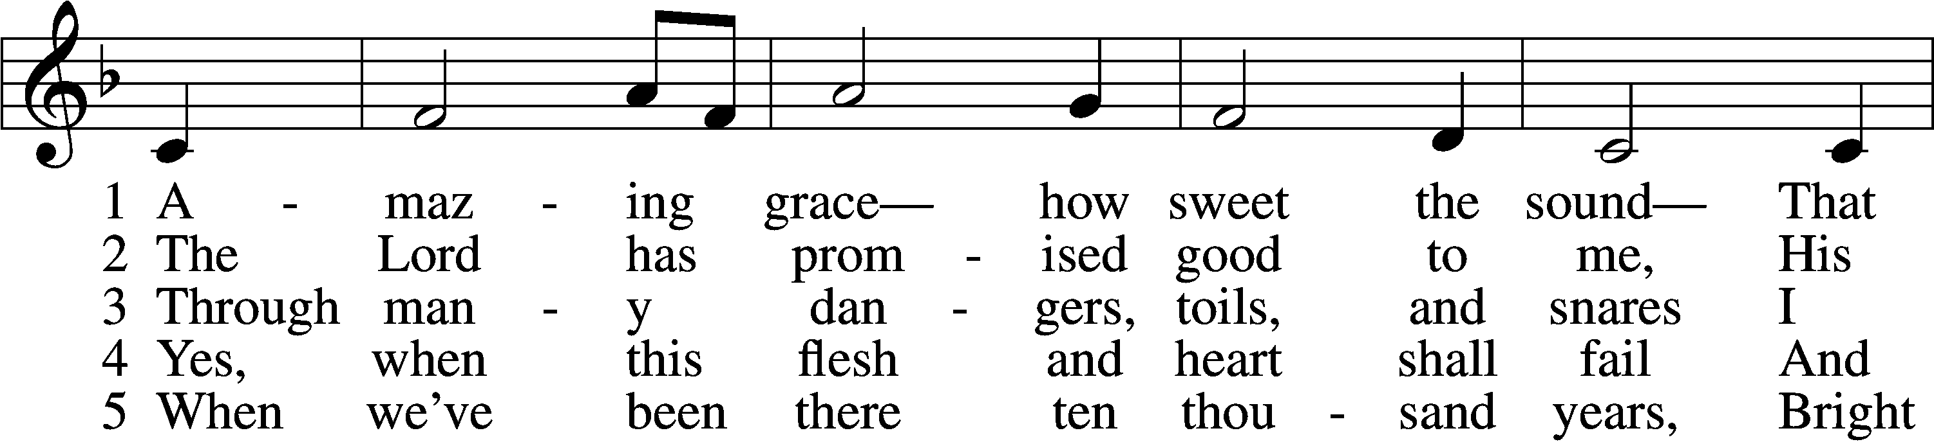
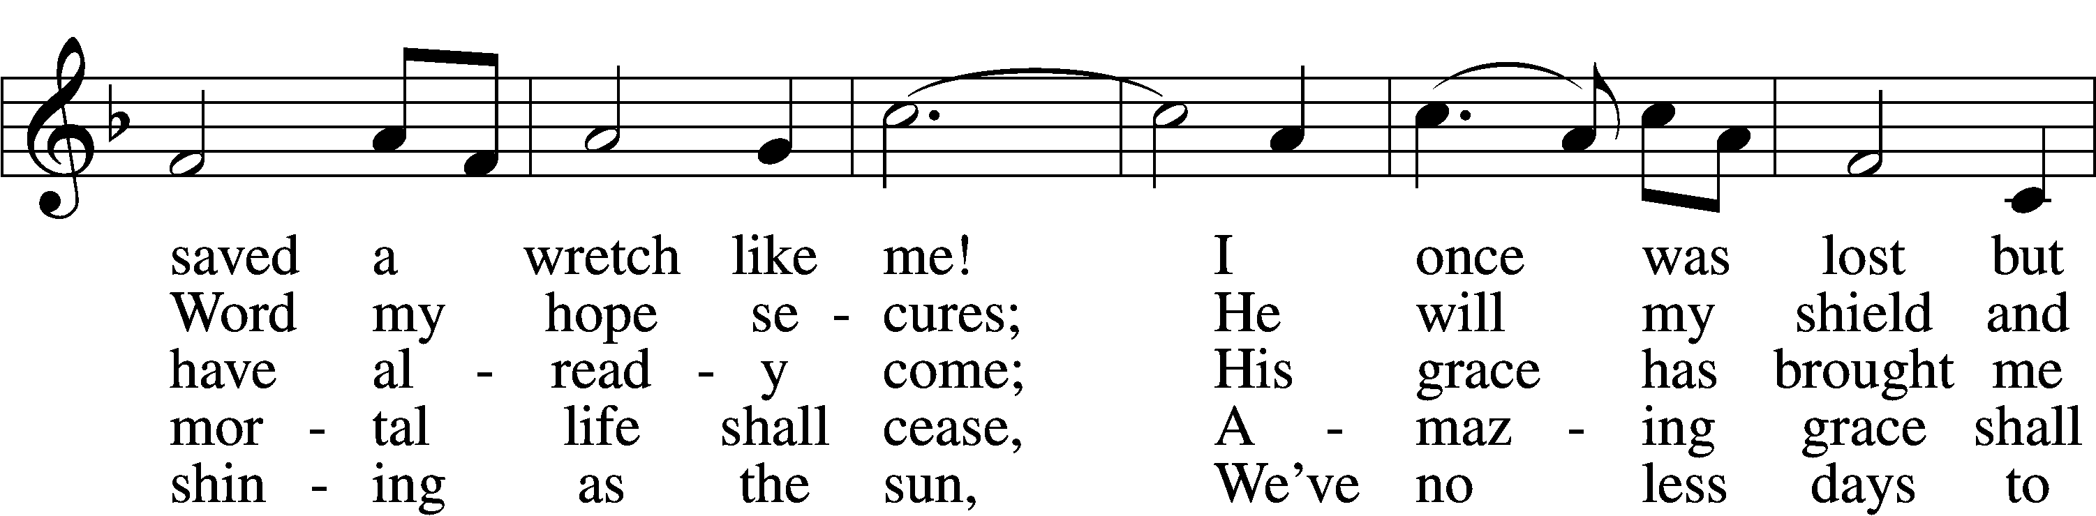
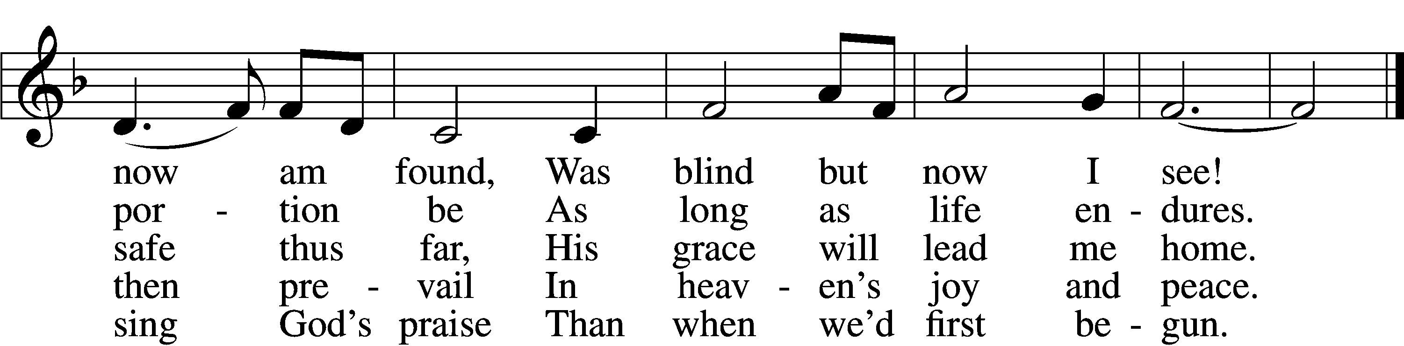
Text (sts. 1–4): John Newton, 1725–1807, alt.; (st. 5): A Collection of Sacred Ballads, 1790, Richmond
Tune: Columbian Harmony, 1829, Cincinnati
Text and tune: Public domain

Choir: "Go Now in Peace"
Postlude - “March Solonelle” by Charles Gounod.

All are invited to join the congregation for a light luncheon over in the fellowship house.

Acknowledgments
Funeral Service from Lutheran Service Book
Unless otherwise indicated, Scripture quotations are from the ESV® Bible (The Holy Bible, English Standard Version®), copyright © 2001 by Crossway, a publishing ministry of Good News Publishers. Used by permission. All rights reserved.
Created by Lutheran Service Builder © 2025 Concordia Publishing House.

